
Culture Plan
Dundee east Girls Football Club
Last updated | 03/11/2022

DECSC CULTURE PLAN – AN ATTRACTIVE MODERN GAME

AN ATTRACTIVE GAME
We are striving to create a culture and environment that attracts, retains whilst developing all our players, coaches, and officials.

HOW WILL WE LOOK TO ACHIEVE THIS?

Working closely with Affiliated National Associations (ANAs), leagues, club’s and schools to modernise the National Player Pathway/promoting a player-centred philosophy via the integration of the new Positive Coaching Scotland Plus plan across all areas of the game.
Working with & creating links with a wide range of partners to identify, plan and resource, new and improved facility provisions.
Integrating the Scottish FA Child Wellbeing and Protection, directive, ensuring consistency across all areas of the game.

FOOTBALL FOR LIFE



The overarching vision of the One National Plan, Football for Life, aims to provide
opportunities for every person in Scotland to participate and develop through the
national game. This in turn will grow the value and benefit of football for individuals,
communities and society alike.

Football for Life aims to grow the game across Scotland by making it more attractive and sustainable. This will be achieved through initiatives that increase participation, deliver education and enhance the services clubs bring to their communities.
Beyond growing the game, Football for Life encourages lifelong participation – not only increasing participation in the game but ensuring that once players are involved in football they stay in football for life.
These three outcomes are a key part of the new brand: Football for All; Skills for Life; and Clubs for Communities. Dundee East Community Sports Club are fully committed to delivering the above through our existing initiatives as well as delivering new ones as part of our Football Plan.

FOOTBALL FOR ALL



Football for All focuses on growing the game. It aims to grow the scale and diversity of football participation in Scotland by increasing recruitment and retention of participants, regardless of age, gender, background or ability.
A huge variety of forms of football are already on offer across Scotland, from walking
football to over-35s Football to Para football. Football for All aims to continue this steep upward trend of ensuring that football is available to anyone who wants to become involved.

SKILLS FOR LIFE
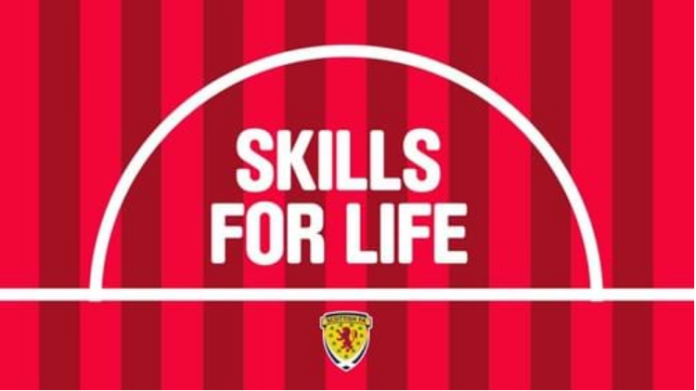

Football offers so much more than an enjoyable sporting activity. Participation delivers real-world, invaluable skills such as teamwork, leadership, respect, an appreciation of the importance of hard work and resilience – or in football terms, bouncebackability.
Skills for Life also relates to supporting the growth and sustainability of the game, this time through the development of Scottish Football’s volunteers, referees and coaches.
Existing education courses will continue to be developed to increase their range, reach and impact, while every effort will be made to nurture a positive culture throughout grassroots football to further incentivise the development of talent.
Skills for Life encompasses programmes such as the Lidl Skills Centres; the Cashback
Schools of Football; coach and referee Development; and Positive Coaching Scotland.
END OF PLAN

